

Gone sin Mal

Setting Test Environment and Build Guide



Bit Geeks

Min Thu Khant

Contents

1. Introduction 2

2. Configuring Network 2

3. Setting Up Web API 4

3.1 Creating Database 4

3.2 Running Web API 5

4. Setting Up Mobile Application 5

5. Running Application 6

5.1 Option 1 – Using Expo Mobile App 6

5.2 Option 2 – Using Android Emulator 6

6. Building Mobile Application 7

6.1 Building Front end 7

6.1 Building Web Api 7

7. Conclusion 7

# 1. Introduction

This is the guide for setting Test Environment and build procedure for both Application and Web API.

# 2. Configuring Network

Mobile app users will be accessing the API via their phones via the same network, even though default will be localhost. Localhost can only be accessed via host computer and cannot be accessed other devices. Therefore, host computer has to configure. The steps are shown in below.

1. Open control panel and search for “Turns Windows features on or off” and open it.

2. Make sure the following services are marked and press “OK”.

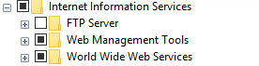

3. Open Internet Information Services(IIS) Manager (can search in window search bar). Right Click on the **Default Web sites** and press **Edit Binding.**

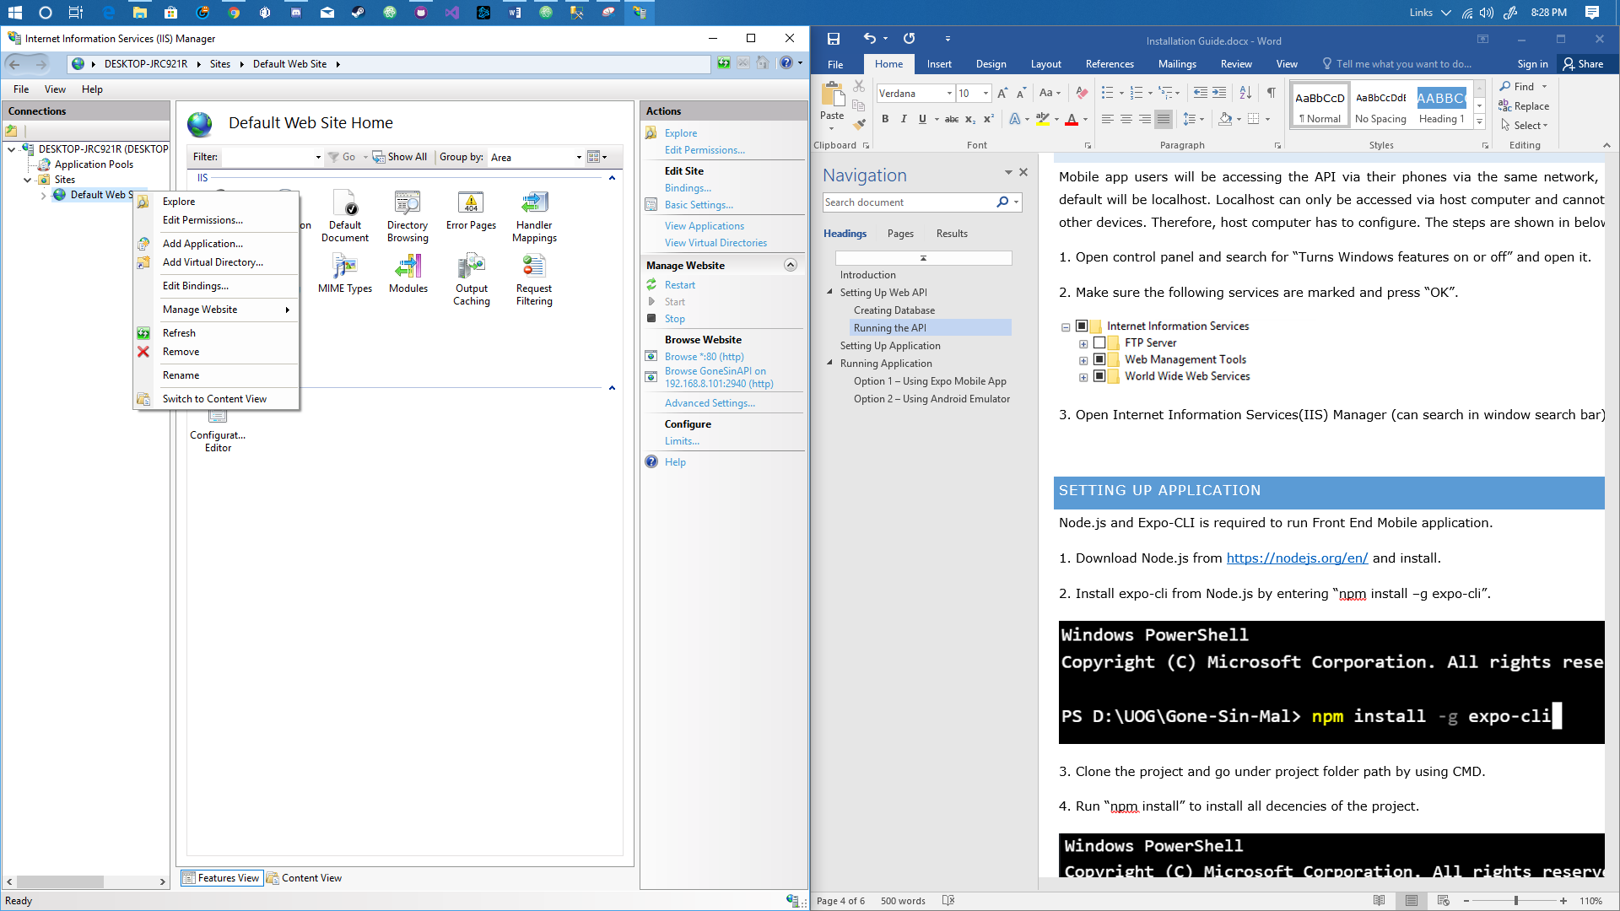

4. Add a binding with port number of “2940”, current IP address and the desired hostname. Then press “OK”

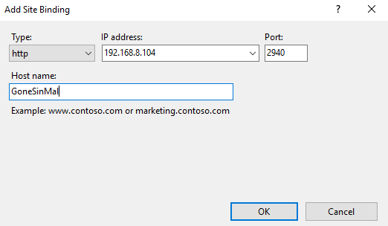

5. Open “Firewall Advance” Setting. Then Select “Inbound Rules” and click now “New Rules” on the left side of the window.

6. In the appeared window, Select **Port**->Next-> **2940** in specific local ports->Select **Allow the connection**->Next->Next-> Enter desired name and click “**Finished**”

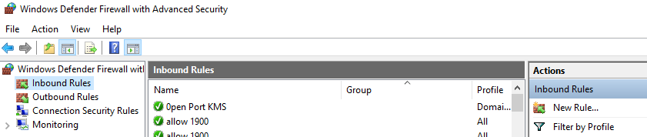

# 3. Setting Up Web API

API is needed to serve data exchange and execute business logic for the whole application. Therefore, API is required to run first for the whole application to work. To run the web API, the following steps must be carried out.

## 3.1 Creating Database

1. Clone the Project and run the open the SQL file named “CreateDatabase_Tables” under project folder.

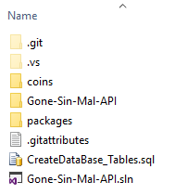

2. Run all create table queries and run System Insert command provide in the file.



3. Change the path of Coin Images to related path of the current computer in Insert statement of Package Table and run those queries. Coin Images are located under **coins** folder which is under project folder.



## 3.2 Running Web API

1. A configuration file is needed to edit before running the API. Open the configuration file under **ProjectFolder/.vs/config.**

2. Search for “2940” and replace the selected IP address with your current IP address.

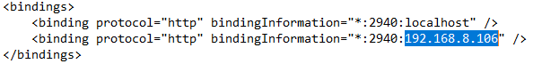

3. Run Visual Studio with as “Administrator”, open the project

4. Make sure Database connection is opened for entity framework and run the Web API.

# 4. Setting Up Mobile Application

Node.js and Expo-CLI is required to run Front End Mobile application.

1. Download Node.js from <https://nodejs.org/en/> and install.

2. Install expo-cli from Node.js by entering “npm install –g expo-cli”.

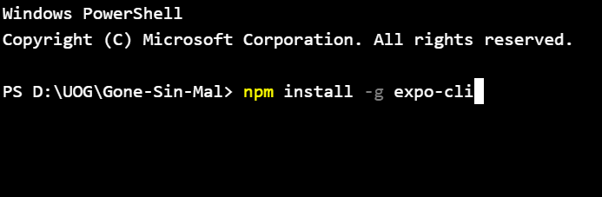

3. Clone the project and go under project folder path by using CMD.

4. Run “npm install” to install all decencies of the project.

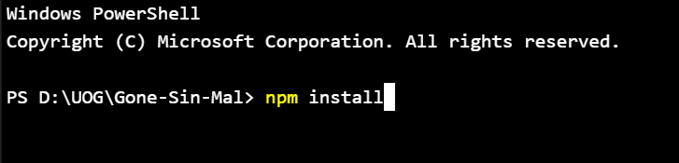

5. change the IP address inserted in global.HostURL in App.js to current IP Address.

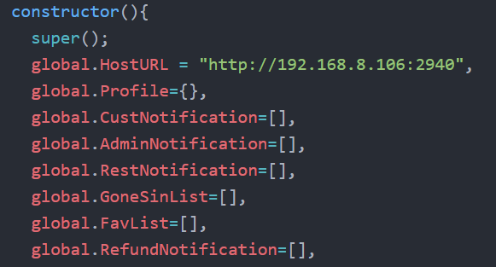

6. Type “expo start” to run the project. Web debug view of the Expo will appear in browser.

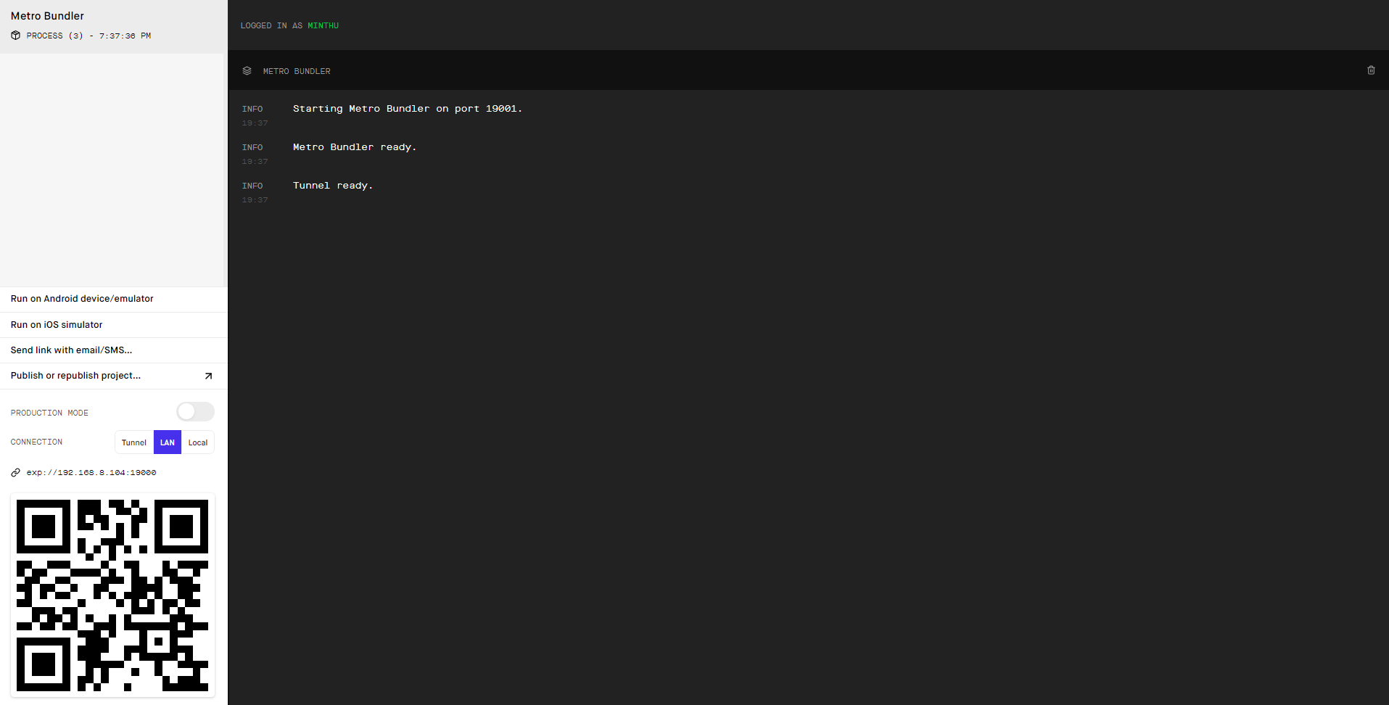

# 5. Running Application

## 5.1 Option 1 – Using Expo Mobile App

Built project can be run in Mobile Phone via Expo Mobile Application.

1. Download the expo application into phone.
2. Expo login is required to get Notification token work. My account is recommended if **APK** file will be generated since it is registered under my account. (**Email:** [minthukhant.it@gmail.com](mailto:minthukhant.it@gmail.com), **Password:** minthuitkhant).
3. Scan the QR code from the web view with the expo app. Wait for it to build and the project will open in mobile phone.

## 5.2 Option 2 – Using Android Emulator

If the computer to run the application is good enough to handle, android emulator can be used also.

1. Firstly, Android Studio 3.0+ is needed to be installed.
2. Go to **Preferences -> Appearance & Behavior -> System Settings -> Android SDK**. Click on the "SDK Tools" tab and make sure you have at least one version of the "**Android SDK Build-Tools**" installed.
3. Create a virtual device and run it.
4. Click on “run on Android device/emulator” in expo web debugging tool to install expo and run the project in emulator.

More detailed instructions can be show in the following link:

<https://docs.expo.io/versions/v32.0.0/workflow/android-studio-emulator/>

# 6. Building Mobile Application

## 6.1 Building Front end

1. Expo account must be logged with My account mentioned from above in Expo-cli. Type expo login to login.

2. Run “**expo build:android**” command. This will build both Android and IOS app in expo cloud and will be able to download after a success build.

## 6.2 Building Web Api

As for the Asp.net web API, built DLL files can be found in default build folder.

# 7. Conclusion

Most of the above steps are only need to perform only once to run in local environment. Steps as mentioned from **Header 3.2 Running Web API** and changing IP address of global.HostURL will have to change only if IP address of the host computer is changed. However, if Web API is hosted on internet, global.HostURL in Front End App.js will have assign with address of the Web API and build.